MUHAMMAD OMER SIDDIQUI OOP LAB 6

19B-004-SE(A)

CASE STUDY # 01

#Case Study 1:

class Employee:

def Person(self):

print("I am an Employee")

class Programmer(Employee):

def Person1(self):

print("I am also a Programmer")

D1 = Programmer()

D1.Person()

D1.Person1()

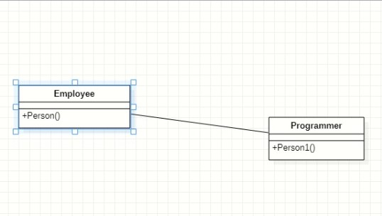

#Case Study 2:

class Employee:

def Person(self):

print("I am an Employee")

class Programmer(Employee):

def Person1(self):

super().Person()

print("I am a Programmer")

class Designer(Employee):

def Person2(self):

print("I am also a designer as well")

D1 = Programmer()

D2 = Designer()

D1.Person1()

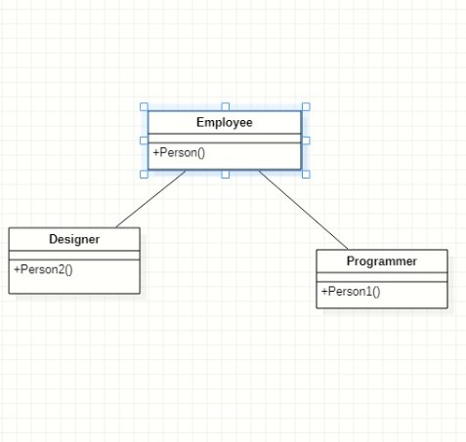D2.Person2()